Creating a Weighted Column in Blackboard Grade Center
Begin by setting up your categories – quizzes, class work, assignments, etc.
To do this, go to the Grade Center, click the Manage button and choose Categories.
Blackboard has some built-in categories such as Assignment, Test and Discussion, for example, and items are automatically added to these categories when an assignment, test or discussion is created.
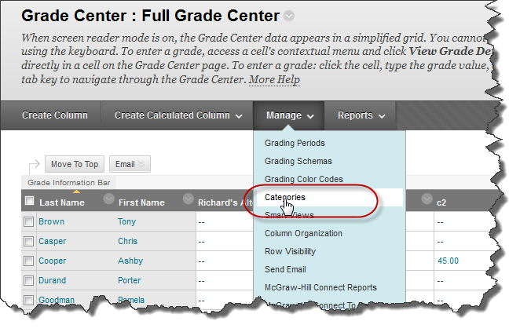
You can define your own category by clicking the “Create Category” button.
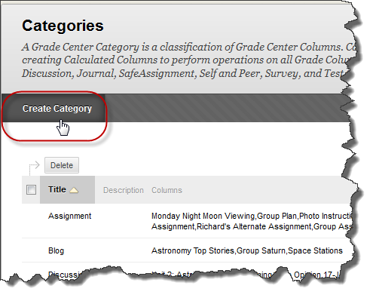
Once your categories are defined, you are ready to create your Weighted Column. To do this, go into the full grade center and in the top row of buttons, click the Create Calculated Column button, and then choose Weighted column.
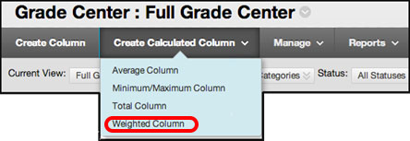
A page will open called COLUMN INFORMATION.
Give your column a name – Current Grade, Final Grade, etc.
Set the Primary Display to “Score.”
You can choose either categories or columns, or a mixture of both to include in your calculated column.
Select the item, then click the right chevron icon. That is Geek Speak for the little arrow icon in a box. Clicking this will move the item into the Selected Columns area.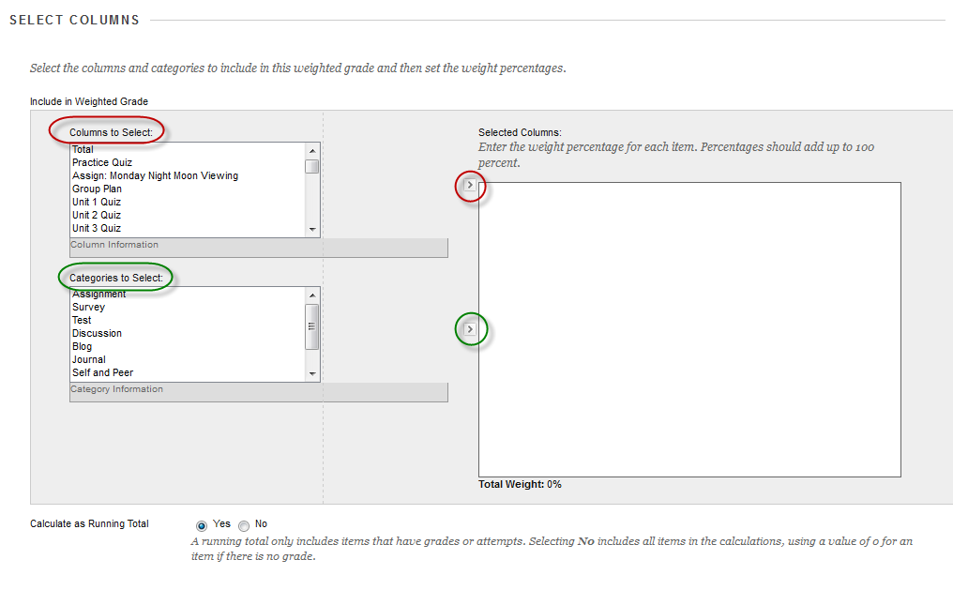
In this example, I am going to choose the “Test category” and click the right chevron icon.
The Test category now appears in the Selected Columns area and I can assign a value of 20% to it.
Blackboard will keep track of the total percentages and warn you if you try to finish and the total is less than 100%.

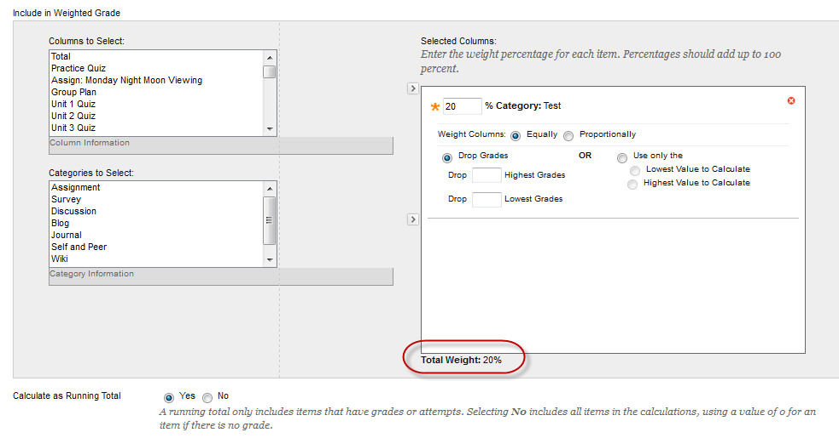

Here I have selected the Group Assignment column and added it to the Selected columns area. I assigned it a value of 10% and notice that the total changed to reflect this.
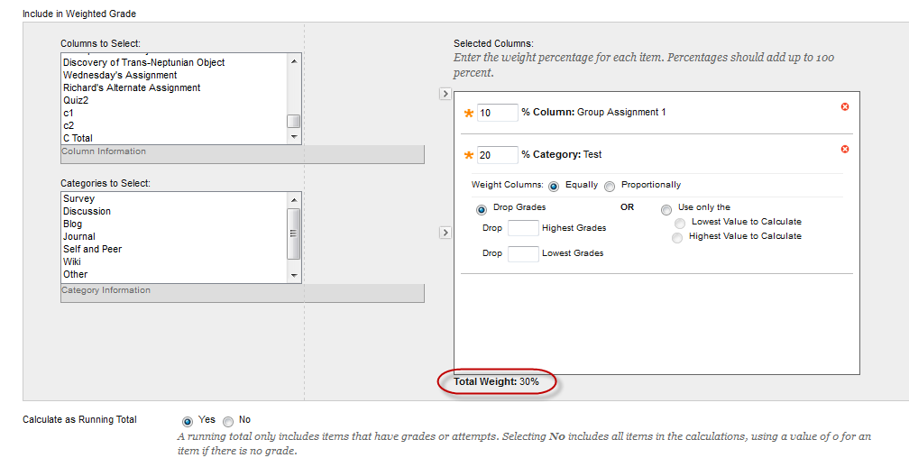

In this example, there are several tests. If all the tests are worth the same number of points (usually 100), then let Blackboard weigh the columns equally. If one or more are worth more, then choose to weigh them proportionally.
As you add more items, scroll bars will appear in the Selected Columns area. One of Blackboard’s quirks is that in this window new items are added to the top of the list, but not always. If you make a selection and do not see anything change in the Selected Columns area, scroll to the bottom and see if Blackboard decided to add it to the bottom of the stack instead of the top.
After you enter all the categories and columns and your total is 100%, you are almost finished.
The only other decisions you need to specify is if Blackboard should use a running total calculation, set your options and then click the Submit button.
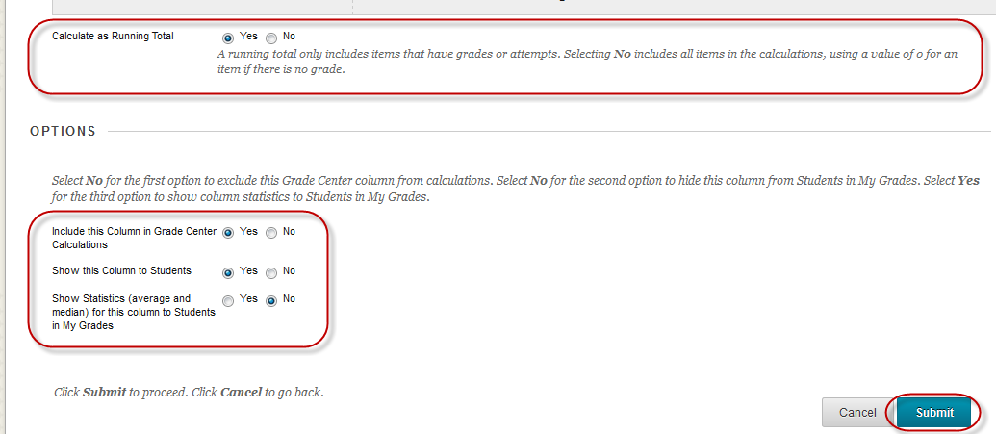

The new Weighted Column will be added to right end of the Grade Center.
The order of the columns can be changed by clicking the Manage button at the top of the Grade Center and then choosing Column Organization. Change the order by clicking and dragging the icon.

The Column Organization page will also show you the category for each of your columns.
You can click the box beside the item and then use the “Change Category to…” button at the bottom of the page.
Your Weighted Column will be automatically recalculated to reflect any changes made.

